**Matrix Factorization for Collaborative filtering**

Matrix factorization is decomposing of matrix into two matrix.

Consider matrix A, it is a sparse matrix i.e it have many empty cells,

Cell Aij : is rating on Itemj by useri

Lets apply MF on A which is shown below

Here A factorize into B and C

Such that dimension of B : n*d , C: m*d and d>0 and d <= m and d<= n

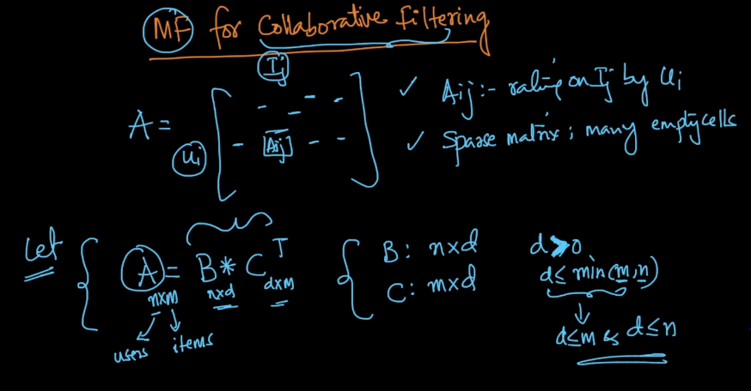

Any cell Aij we got by multiplication of Bi and Cj where Bi and Cj are column vector of dimension d*1 each representing rows of B and C.

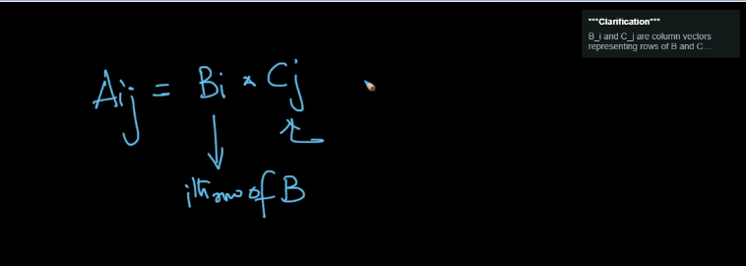

So as Aij is single value of dim 1*1 and B and C are of d*1 therefore we got value of Aij by multiplication of BTi * Cj , here Bi and Cj are column vectors representing rows of B and C

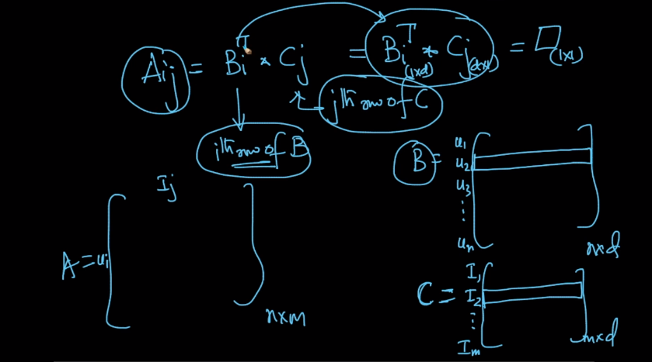

So as we got Aij by BTi * Cj we can complete A (i.e find values of empty cells) by applying optimization like SGD to get B and C such that obtained values from B*CTfor non-empty cells should be approxy equals to same non-empty cell in original A matrix

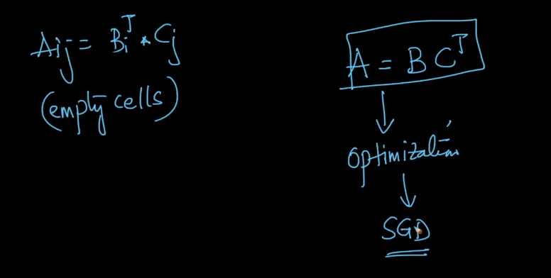

In below fig. we are finding B and C full matrices by applying optimization and we are taking only those cells(I,j) of A such that Ai,j is not empty and by this only we got full matrices of B and C and by taking dot product of this obtained B and C we got a new Matrix A_hat now as we solve optimization problem using non-empty cell of A matrix therefore same non-empty cells of A and A_hat should be approxy same. And values of all empty cells we got from A_hat

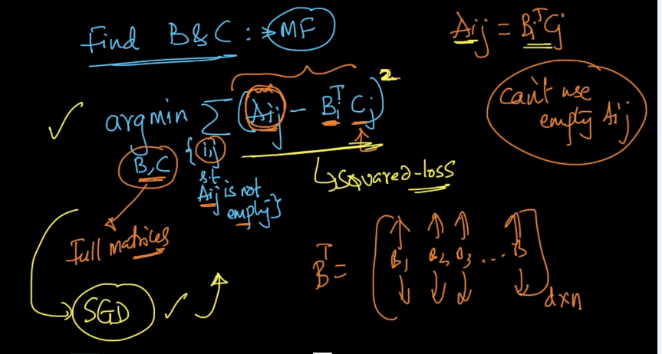

Therefore after solving optimization problem we got B and C matrix as shown below

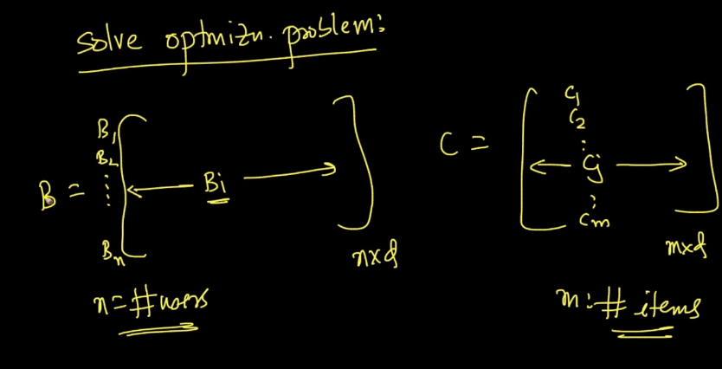

Steps of matrix factorization for collaborative filtering is shown below :

1. Solve optimization problem using SGD to find B and C
2. We got B (n*d)and C(m*d)
3. We do matrix completion A_hat(n*m) = B * CT  and by this we fill empty cells in A

Suppose we have empty cell A10,5 in A so we can get this value from A_hat :

A10,5 = BT10 * C5

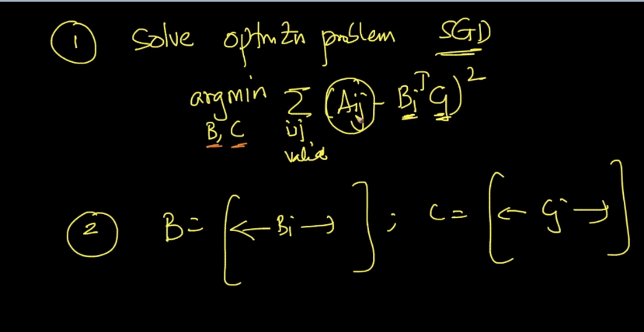

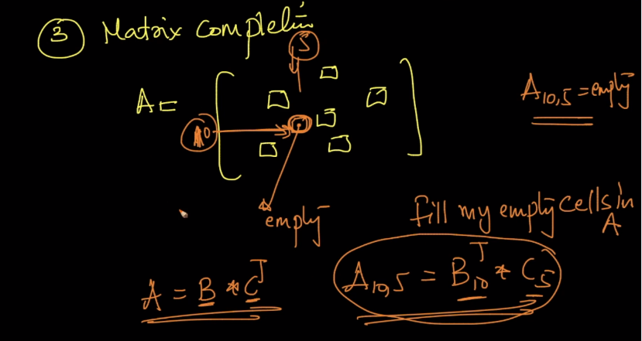

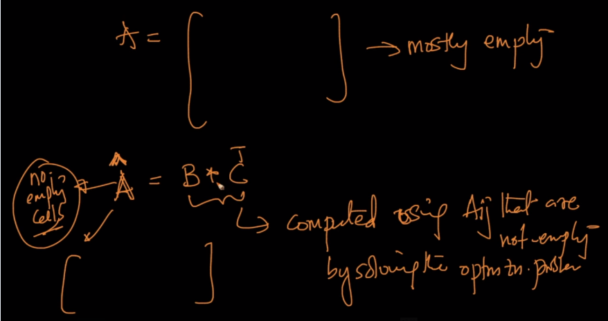

Diff. of non-empty cell of A and A_hat should be very small.

And A_hat is completed form of A because it contains values that are empty in A

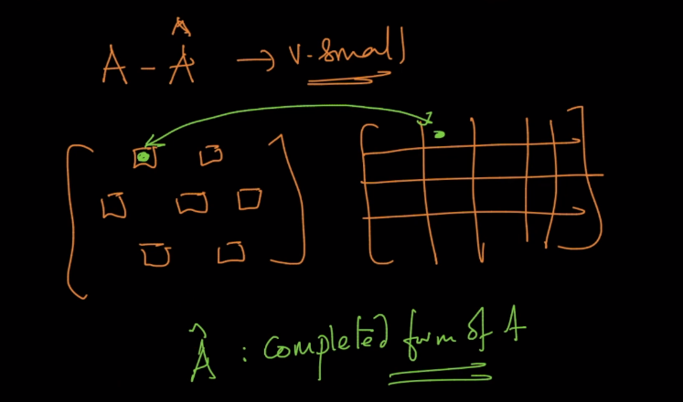

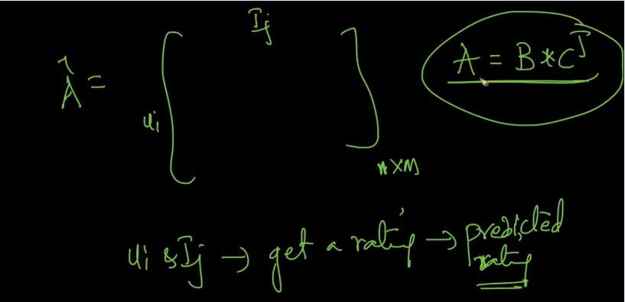

A(Actual rating) approxy same as A_hat(predicted rating)

Therefore we can predict/get a rating of user i on Item j

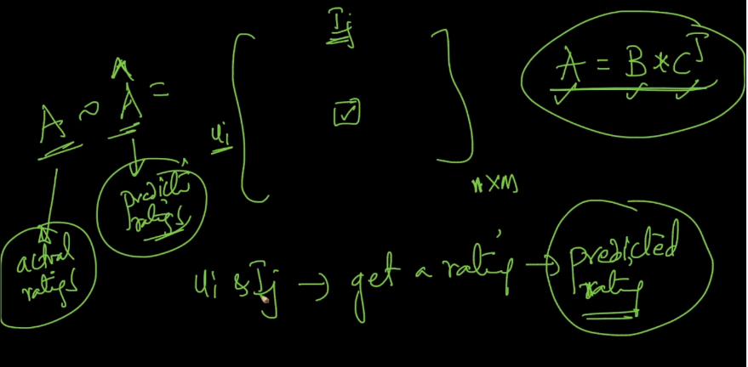

From above we can say that we can use MF for collaborative filtering as we can predict ratings for items which users haven’t watched yet.

Application of MF is in many areas like PCA, CF, Feature eng., clustering

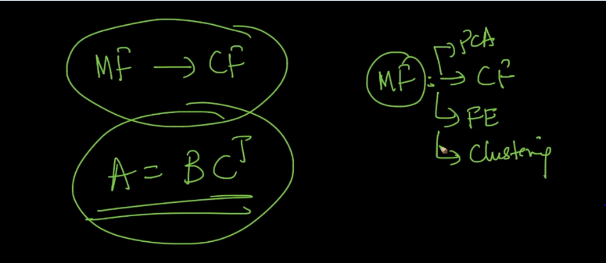

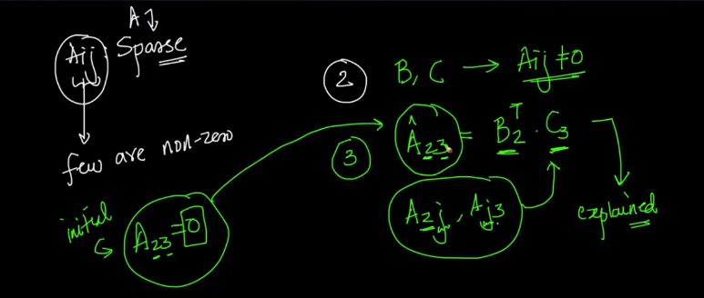

Comments:

